1. First, I installed SQL Server. I only installed the Express Edition, since this version is free and it satisfies the needs of this project. The link to the download page can be found here:

<https://www.microsoft.com/en-us/sql-server/sql-server-downloads>

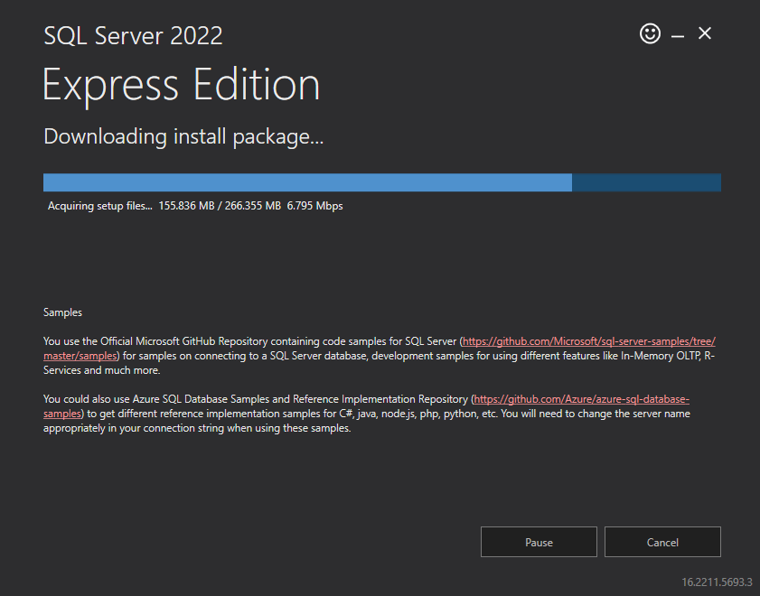

1. Here are some important details about the database instance.

Instance Name: SQLEXPRESS

SQL Server Install Log Folder: C:\Program Files\Microsoft SQL Server\160\Setup Bootstrap\Log\20230111_201134

Connection String: Server=localhost\SQLEXPRESS;Database=master;Trusted_Connection=True;

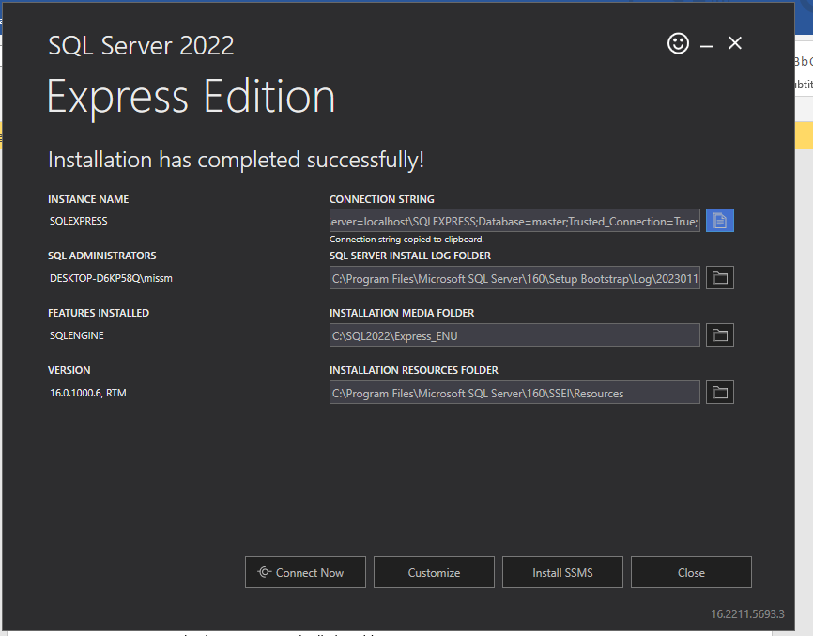

1. Next, I clicked the button “Install SSMS” to install the database management system for SQL Server, SQL Server Management Studio. Here is the download page:

[Download SQL Server Management Studio (SSMS) - SQL Server Management Studio (SSMS) | Microsoft Learn](https://learn.microsoft.com/en-us/sql/ssms/download-sql-server-management-studio-ssms?redirectedfrom=MSDN&view=sql-server-ver16)

1. While SSMS was installing, I pressed the “Connect Now” button to connect to my new instance, SQLEXPRESS.

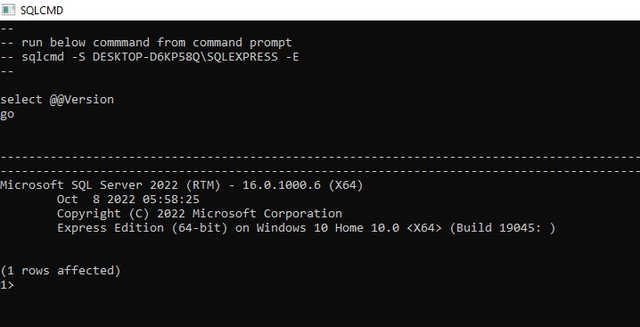

1. After successful installation of SSMS, the newly downloaded app was opened, and the instance name “DESKTOP-D6KP58Q\SQLEXPRESS” was entered.

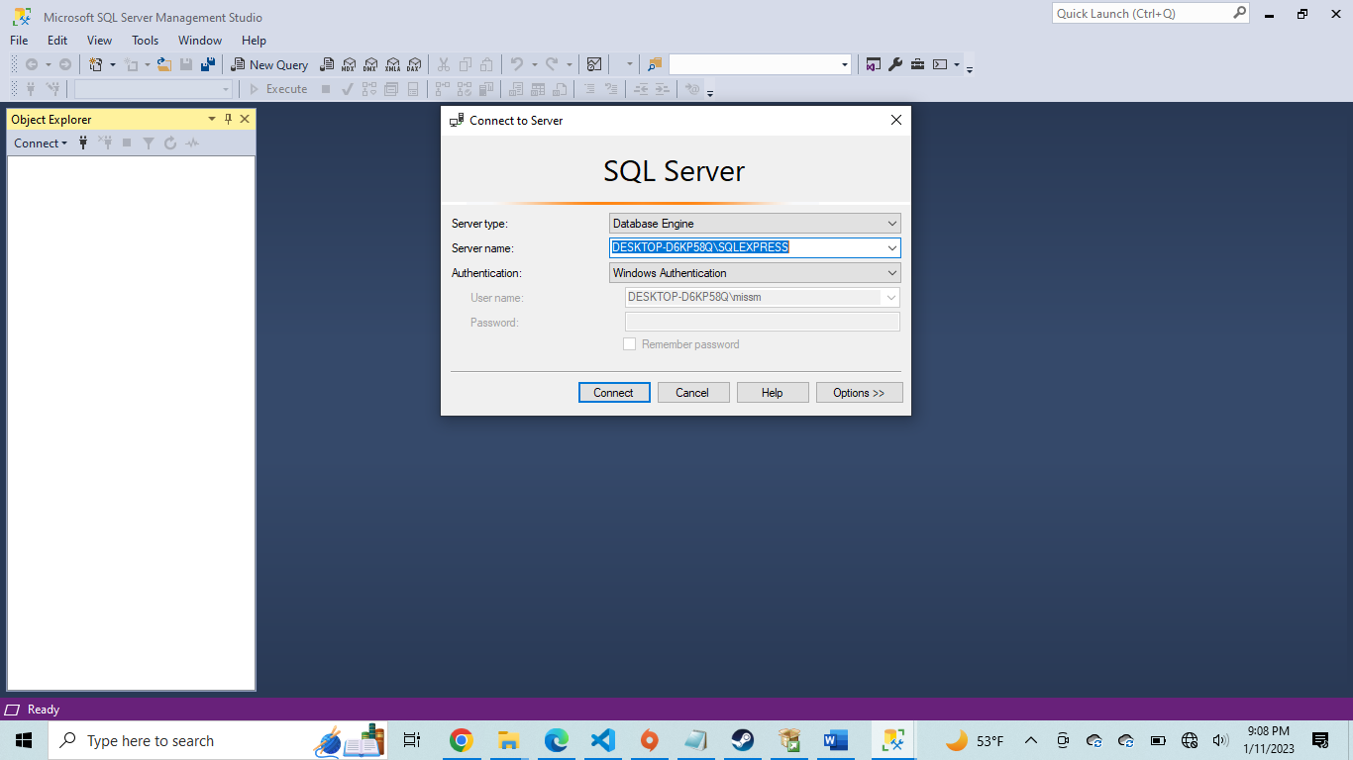

1. The connection was successful.

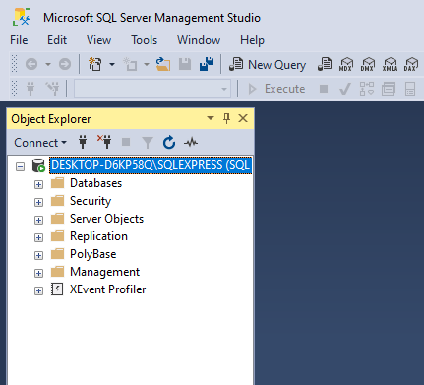

**Discussion on Database Security**

1. Right off the bat, there are several things to do to increase security for this database instance. Normally, a database server should be deployed in an environment-specific server. For example, you may have one database server for development (DEV), quality assurance (QA), user acceptance testing (UAT), or production (PROD). In addition to creating each instance of the database server, the ideal would be to isolate the database server by deploying it in an Azure VM. As this feature does cost money, it is out of scope for this tutorial, but it is very much best practice to put the SQL server in a restricted network segment (such as a subnet). This way, NSG rules can be applied, and servers must be explicitly granted permissions to access.

---

1. It is now time to create a new database. This new database is called Healthcare_Data. The SQL script to create the database is stored in the Repo.

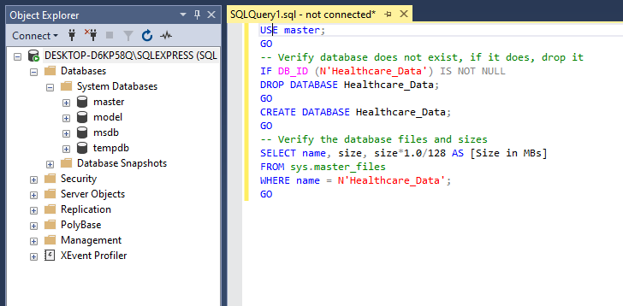

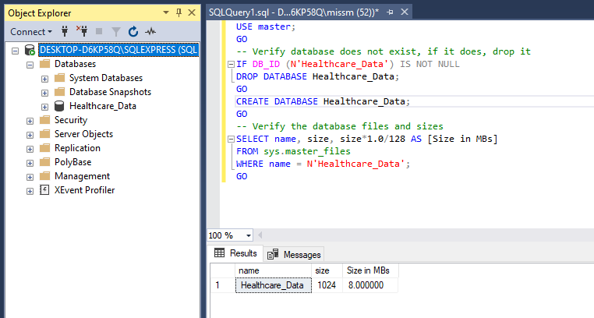

1. A new table was created called ER_Stats. The SQL script to create the table is included in the Repo. This will be the main table that we will be working from to create our reports and dashboards on ER statistics.

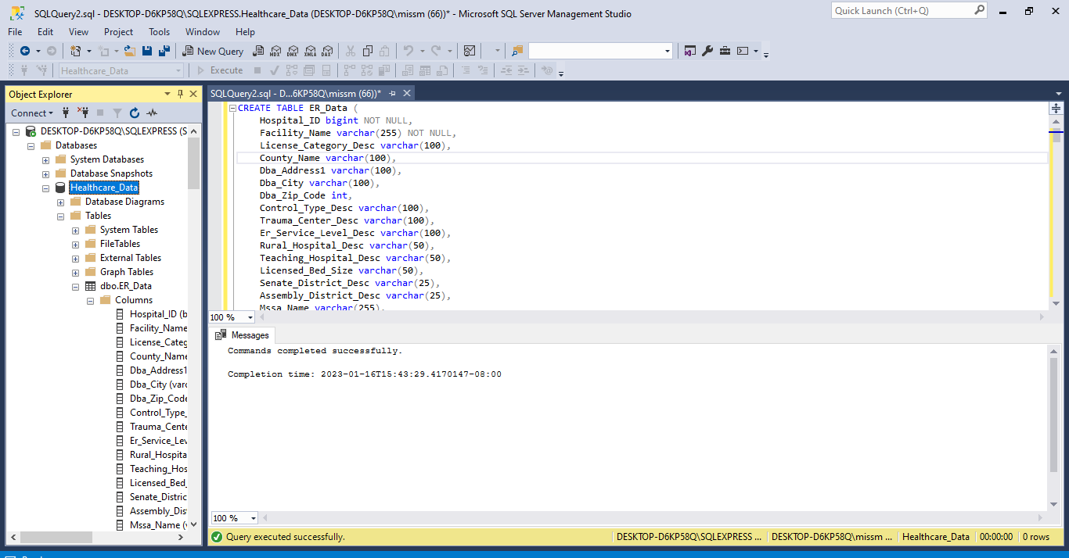

1. Now that the table is created, it’s time to add some data to the table.